Digisim PS1

Part-1

Approach:

1. Delay Generation

The subcircuits SUB1, SUB2, SUB3 and SUB4 are identical and are responsible for generating the delays as well as controlling the up/down counter’s mode of operation. The outputs of the sub-circuits are sent to 4-bit binary synchronous counters.

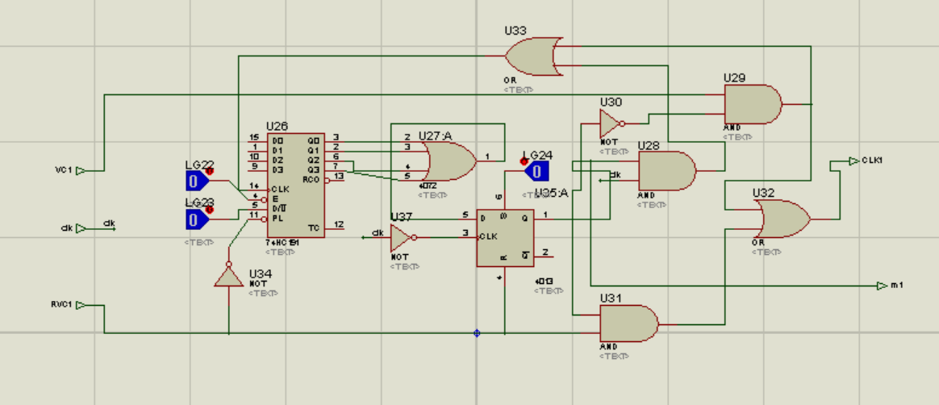

Figure-1: Sub-Circuit SUB1

The counter (connected to the subcircuit) behaves as an up counter when any of the VC buttons are pushed and as a down counter when any of the RVC buttons are pushed.

We have also used a D flip flop in the sub-circuit for its reset condition in case of RVC being pushed.

1. Comparison of Votes

The output from counters is the number of votes received by a candidate. We have used comparators to compare the number of votes. Now, after using two comparators we have to compare the higher votes of both comparisons. So we use a multiplexer and choose the higher number of votes by selecting from the two counter outputs. Then we compare the multiplexer outputs again and get the winner.

1. Winning Candidate and his/her votes

We have attached logic gates according to the expression for LSB and MSB of the winner. To get the number of votes of the winning candidate, we again use a multiplexer. The two multiplexers select the winning number of votes.

Features:

The push button for voting is disabled for the next 15 seconds every time it is pressed. In these 15 seconds, the voter can use the RVC button to reverse his/her last vote.

The RVC button can be used only when the VC button for the respective candidate has been used before (To avoid pressing of RVC without pressing VC).

Multiple voting is allowed. A voter can vote for more than one candidate within the 15 seconds he/she is given for voting.

The winner as well as the winning number of votes are both displayed through logic probes.